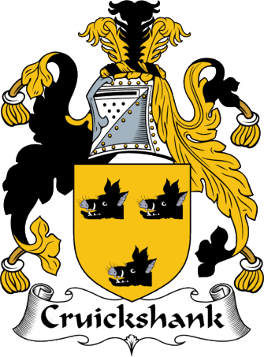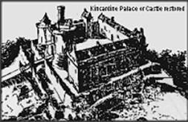

KINCARDINE

OVERVIEW
Kincardine Castle occupied a low hill a couple of miles to the north-east of Fettercairn in present day Aberdeenshire. It is only a pile of masonry now atop a lonely farmland hillock but at one time Kincardine Castle was so mighty that it gave its name to a whole county, as it was a very important and royal castle.
Kincardine Castle was part of the ancient heartland of the royal house of the Kings of Scots. The whole of this area has long been agricultural, drained by canals, although at the time of occupation the area was most likely marshy. Kincardine Castle was positioned to give good views over the low-lying Howe of the Mearns, and access into the hills to the north where the royal party might choose to hunt.
The area also had strategic importance since it guarded the twisting Cairn o' Mount pass leading to Banchory and Deeside.

CASTLE RUINS
The ruins of Kincardine Castle form a simple rectangular courtyard about 35 metres square, with the remains of buildings along the north and east. To the south was a main entrance flanked by two rectangular towers, and a simple arch formed a secondary entrance which faced northwards. Next to the easternmost of the gate towers is a stub of masonry projecting into the courtyard independently of the building to the east. No function has been identified for this, although it may have been part of a platform supporting stairs to the wallwalk over the gatehouse. The walls were battered at the base, a common feature of early 13th century (1200’s) castles, and were about 2.4 metres thick. Today they stand to a maximum height of about 2 metres and the whole site is completely overgrown with vegetation; the hill is also covered with trees, as shown in the links.
A possible terrace around the southern side of the hill may recall an earlier defensive ditch and outer palisade – or be a non-contemporary access track.

KINCARDINE
To the east was the old burgh of Kincardine from which the county took its name. A burial ground and St Catherines Chapel existed within the southern part of this, and features to the north and north-east of the castle known as Gallow Hill and Gallow Knowe indicates the folk memory of another common feature of medieval lordship. The area to the north of the hill used to be known as the Kings Park. There are no visible remains of any features from the burgh.

HISTORY
Although there are traditions associating the vicinity of Kincardine Castle with the death of Kenneth II in 995 AD, it first appears in history as the location for the execution of Guthred MacWilliam in 1212, and features regularly in accounts of the reign of Alexander II – although some of these mentions are non-contemporary. A small excavation resulted in the carbon dating of a pig bone found in a demolition layer to 1040-1220 AD, indicating that it may well date to the reign of Alexander or his father William.
As one of the principal royal estates, one might expect records to be plentiful regarding the history of Kincardine Castle. However, it is not until 2nd July 1296 that it appears in documents again – and on that date King John Balliol acknowledged rebelling against Edward I of England. The castle does not appear in the records of Edward I as having been given a constable – and there are no records of it being destroyed, which makes establishing any history after this date difficult.
In 1323, Robert Bruce gave Alexander Fraser pasture rights in the thanage of Kincardine, and in 1345, David II gave the “castle or manor, and park of Kincardine” to the Earl of Sutherland and Margaret Bruce in barony, which became a permanent grant in 1360. In 1370 the Barony of Kincardine was granted to Walter Leslie, subsequently Earl of Ross. Alexander Macdonald, Lord of the Isles and Earl of Ross, granted the castle and parks to Sir John Scrymgeour in 1440. The decline and fall of the Lords of the Isles in the mid 15th century meant that the barony was suppressed into the Crown, and subsequent grants of lands in the area do not mention either the Macdonalds or the barony – and indeed do not mention the castle. This brief list of references tells us that Kincardine remained – or was perceived to remain – a royal property until the very end of the reign of David II, when it was granted away. The appearance of the castle in the documents of 1345 and 1440 suggest that a dwelling was retained here until that date, but the form of it is unknown, and it may be that it remained a symbol of lordship whilst in ruins. The lack of archaeology at the site means that we do not have any occupation dates – and the considerable destruction of the walls – presumably used as a quarry – means there is no architectural evidence to draw on, although it is likely that the buried portions are preserved better. In 1532, the Earl Marischal believed the burgh of Kincardine was important enough to be turned into the county town. Kincardine Castle was used by Queen Mary (Stuart, Queen of Scots) in the 1560’s, but in 1600 Stonehaven became the county town and both Kincardine town and castle fell into decline. The town slowly depopulated and the mercat (Scots for “market”) cross was transferred to Fettercairn in 1730. By 1789 only a few houses remained, and the castle had long since been abandoned.
Nothing now remains of old Kincardine town and little more of the castle.

GREEN CASTLE
Across the burn and about a mile to the north are the earthworks known as Green Castle, possibly a Pictish fort, which may be a predecessor to Kincardine Castle. This consists of a roughly oval mound with a platform measuring perhaps 7 metres by 35 surrounded by a rampart about 2-3 metres wide at the top, and which drops away some 8-10 metres to a wide ditch and counterscarp bank around the base of the mound. In the north-east corner, a causeway across the ditches meets a break in the rampart indicating the main entrance. This may be a site which was occupied by the kings of Scots – or the lords of the Mearns – much earlier; however, no archaeology has been done here, which is a shame, since it may be one of the earliest castles in Scotland.

The information given above is taken largely from these 2 websites with thanks to those authors. Please check out their pages.

http://thecastleguy.co.uk/castle/kincardine-castle-kincardineshire
http://www.clanstrachan.org/history/lands/kincardine_castle.htm

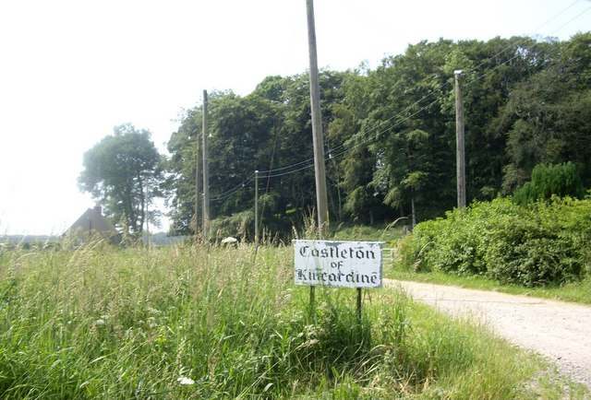
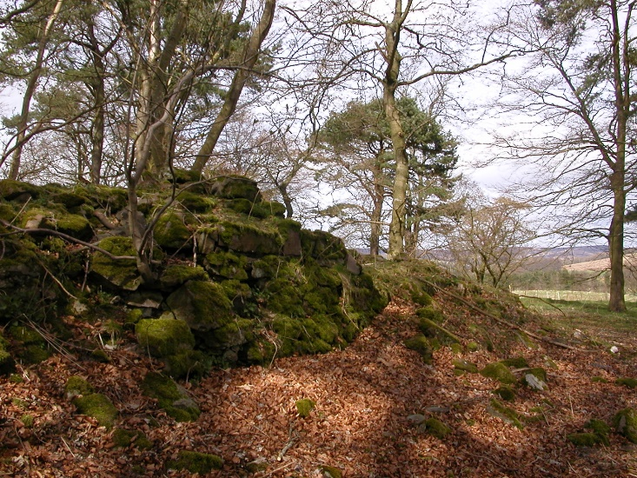

Arrow Points North
(Down)

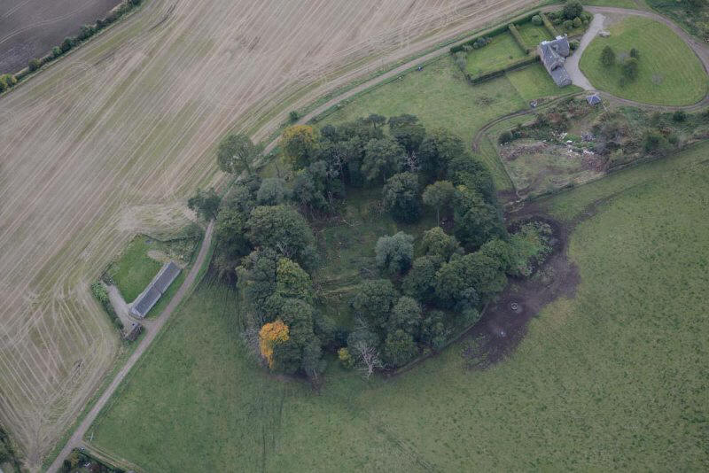

GOOGLE MAPS: https://www.google.ca/maps/place/56%C2%B051'59.4%22N+2%C2%B032'19.1%22W/@56.8631325,-2.5626322,13.88z/data=!4m5!3m4!1s0x0:0x0!8m2!3d56.8665083!4d-2.5386361

STREET VIEW:
https://www.google.ca/maps/@56.8667163,-2.5387004,3a,75y,254.13h,88.57t/data=!3m6!1e1!3m4!1s5WKdxOg3YSObcYOjBGaK5A!2e0!7i13312!8i6656

