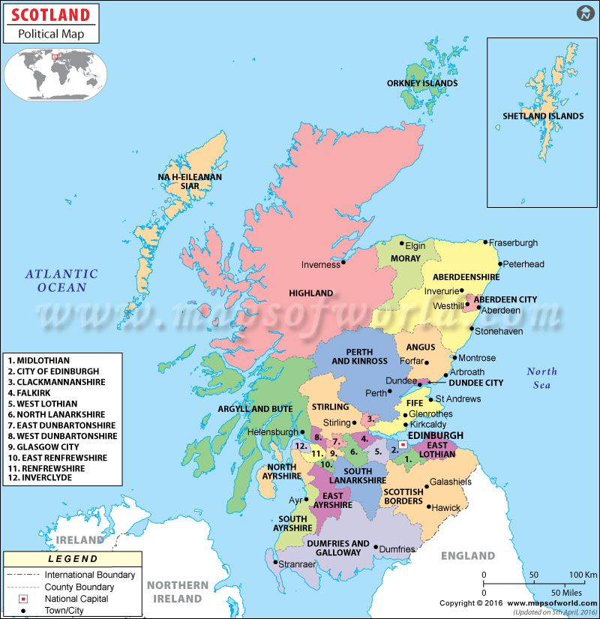

SCOTLAND COUNCIL AREAS
and their CAPITALS (Present day)

